**CookBook - Your Virtual Kitchen Assistant (React Application)**

**TEAM MEMBERS:**

**VARSHA PRADEEP**

**SHALINI.J**

**ATHIRA.H**

**APARNA.S**

**Abstract:**

CookBook is a React-based web application designed to be a virtual kitchen assistant, helping users manage their recipes, plan meals, and track ingredients efficiently. The application provides an intuitive interface, allowing users to search, store, and categorize recipes. Additionally, CookBook offers smart suggestions based on available ingredients and user preferences, making meal planning more convenient and personalized. It aims to reduce food waste and optimize grocery shopping by keeping track of ingredient availability.

**Introduction:**

Cooking and meal planning can be time-consuming and overwhelming, especially for individuals managing busy schedules. CookBook simplifies this process by providing an interactive and intelligent kitchen assistant. This React-based web application leverages modern web technologies to create a seamless user experience, allowing users to access and organize their favorite recipes, generate shopping lists, and receive customized meal suggestions. The integration of artificial intelligence ensures that recommendations are personalized based on user history and preferences.

**Project Overview:**

CookBook is built using React.js for the front end, with backend services powered by Node.js and a MongoDB or Firebase database for storing user information and recipes. It follows a modular architecture for scalability and performance optimization. Key functionalities include:

* **Recipe management** (add, edit, delete, and categorize recipes)
* **Meal planning and scheduling** (weekly and daily meal planning features)
* **Ingredient tracking** (inventory management and tracking of available ingredients)
* **Shopping list generation** (auto-generated lists based on missing ingredients)
* **Smart recipe recommendations** (AI-powered suggestions based on preferences and available ingredients)
* **User authentication and personalization** (secure login, profile management, and personalized recommendations)

**Module Description:**

**1. User Authentication Module**

* User registration and login using JWT authentication
* Profile management with dietary preferences and allergens tracking

**2. Recipe Management Module**

* Add, edit, delete recipes with images and detailed instructions
* Categorization based on cuisine, diet type, and preparation time
* Search and filter functionality for quick access

**3. Meal Planning Module**

* Weekly and daily meal planning calendar
* Integration with stored recipes and ingredient availability
* Notifications and reminders for meal prep

**4. Ingredient Tracking Module**

* Real-time inventory management
* Automated deduction of ingredients when a recipe is used
* Expiry date tracking and waste reduction alerts

**5. Recommendation Engine**

* AI-powered personalized recipe suggestions
* Ingredient-based recommendations to maximize pantry usage
* Seasonal and trending recipe suggestions

**6. UI/UX Module**

* Responsive design adaptable for desktop and mobile devices
* Intuitive user interface with drag-and-drop meal planning
* Dark mode and accessibility features for a better user experience

**System Analysis:**

**Feasibility Study:**

**Technical Feasibility:**

The application is developed using React.js with Redux for state management, ensuring scalability and efficiency. Cloud-based databases such as Firebase or MongoDB enable seamless data storage and retrieval.

**Economic Feasibility:**

CookBook is cost-effective as it primarily relies on open-source technologies. Hosting and database costs are manageable through cloud service providers.

**Operational Feasibility:**

The application simplifies meal planning and kitchen management, making it highly beneficial for users looking to organize their cooking routines efficiently and reduce food waste.

**Existing System**

Currently, meal planning and recipe management are often done manually or through multiple applications that lack integration. Many existing solutions fail to provide ingredient tracking, smart recommendations, and a seamless user experience, making CookBook a more effective alternative.

**Proposed System**

The CookBook application provides an all-in-one solution for recipe management, meal planning, ingredient tracking, and AI-powered suggestions. It integrates seamlessly with user preferences and dietary restrictions to offer a customized kitchen experience.

**Support System:**

CookBook will provide:

* **User guides and FAQs** for easy onboarding
* **Chatbot support** for instant troubleshooting
* **Community forums** for sharing recipes and cooking tips
* **Email and live chat support** for advanced troubleshooting

**System Testing:**

**Unit Testing**

Each module (recipe management, meal planning, etc.) is tested individually to ensure correctness and functionality. This involves testing all functions in isolation to identify and fix bugs early in the development process.

**Integration Testing**

Different modules are integrated and tested to verify seamless data flow and interaction between components. The primary objective is to ensure that all modules work together as intended without data corruption or loss.

**Functional Testing**

Ensures that all application features work as expected according to requirements and user expectations. Each function is tested against specified conditions to confirm it performs the desired operation.

**Performance Testing**

Performance testing is conducted to measure the application’s speed, responsiveness, and stability under different conditions. Load testing is performed to determine how the system handles multiple users simultaneously.

**Security Testing**

Security testing ensures user data safety by checking for vulnerabilities such as SQL injections, XSS attacks, and unauthorized data access. Encryption techniques are used to protect sensitive information.

**Whitebox Testing**

Developers test the internal code structure to optimize performance, security, and maintainability. This ensures the application follows best coding practices and is free from logical errors.

**Blackbox Testing**

Testers evaluate the application based on user interactions, ensuring a bug-free and user-friendly experience. The focus is on verifying that inputs and expected outputs match correctly without exposing internal code structures.

**Future Enhancements:**

* **Mobile Application:** Developing a dedicated mobile app for iOS and Android to provide an enhanced user experience.
* **Voice Assistant Integration:** Adding voice-controlled functionalities for hands-free cooking assistance.
* **Integration with Smart Devices:** Connecting CookBook with smart fridges and kitchen appliances for automated ingredient tracking.
* **Community-Driven Features:** Allowing users to share recipes, create challenges, and participate in cooking competitions.
* **AI-Driven Personalized Nutrition:** Providing AI-generated meal plans based on health goals, dietary needs, and user preferences.

**Root Directory:**

* package.json & package-lock.json: Define dependencies and scripts.
* README.md: Likely contains project documentation.
* .gitignore: Specifies files to ignore in Git.

**Src/ (Source Code):**

* App.js: Main React component.
* index.js: Entry point for the app.
* App.css, index.css: Styles.
* setupTests.js, App.test.js, reportWebVitals.js: Testing and performance measurement files.
* **Pages:**
  + Home.jsx
  + Category.jsx
  + Recipie.jsx
* **Components:**
  + Navbar.jsx
  + Footer.jsx
  + CategoriesHome.jsx
  + NewsLetter.jsx
  + Hero.jsx
  + About.jsx
* **Styles:** Separate CSS files for different sections.
* **Images:** Various hero images.

**public/ (Static Files):**

* index.html: Main HTML file.
* favicon.ico, logo192.png, logo512.png: Icons.related files.

**Technical Architecture:**

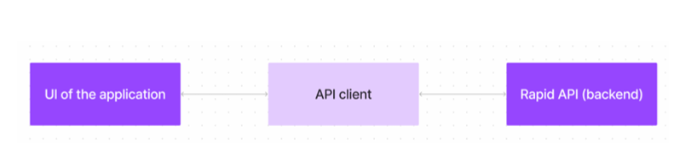

The CookBooks web app uses a React or Vue.js UI for a seamless, single-page experience. It communicates with the backend via a custom API client, integrating external data and features through Rapid API, enhancing the user experience without building everything from scratch.

**Project structure:**

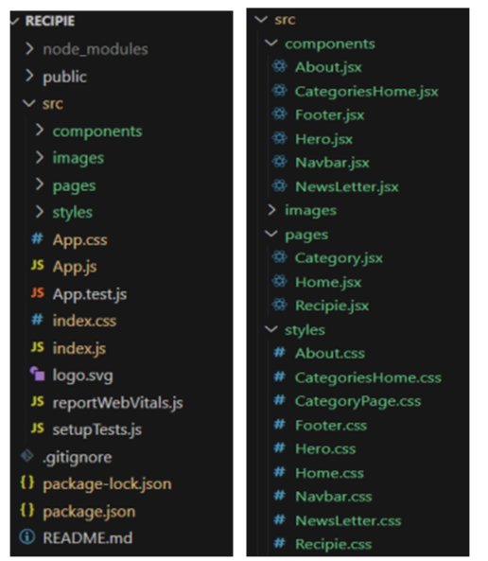

**User Interface snips:**

➢ Hero components

The hero component of the application provides a brief description about our application and a button to view more recipes.

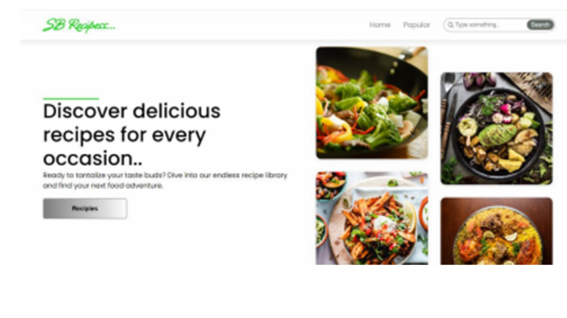

➢ Popular categories :

This component contains all the popular categories of recipes

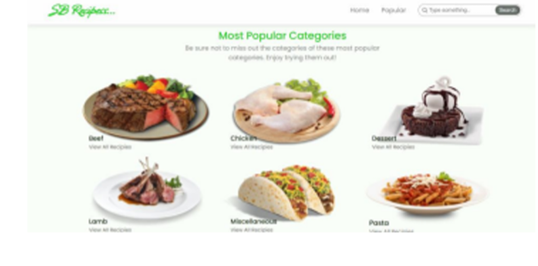

➢ Trending Dishes :

This component contains some of the trending dishes in this application.

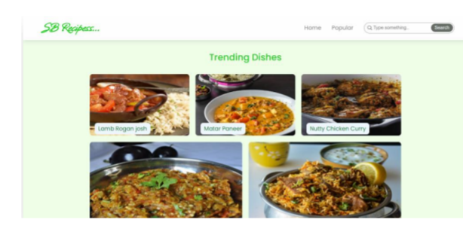

➢ News Letter :

The news letter component provides an email input to subscribe for the recipe newsletters.

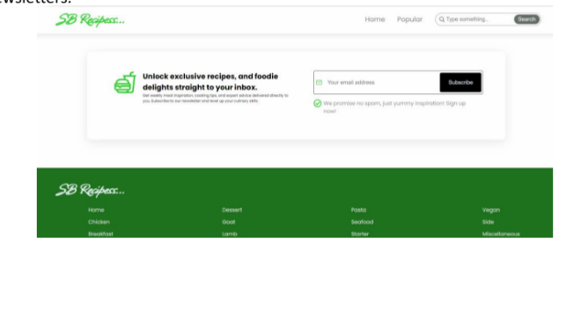

➢ Category dishes page:

The category page contains the list of dishes under a certain category.

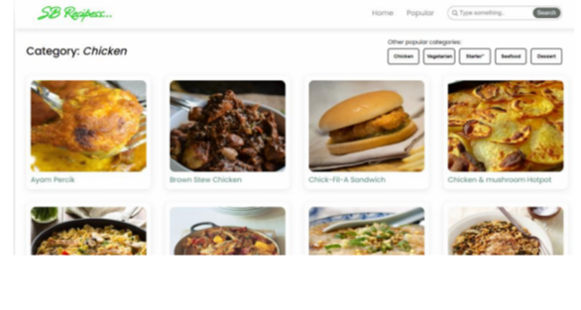

➢ Recipe page :

The images provided below shows the recipe page, that includes images, recipe instructions, ingredients and even a tutorial video.

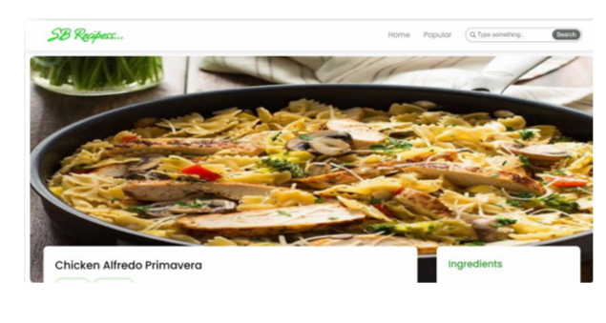

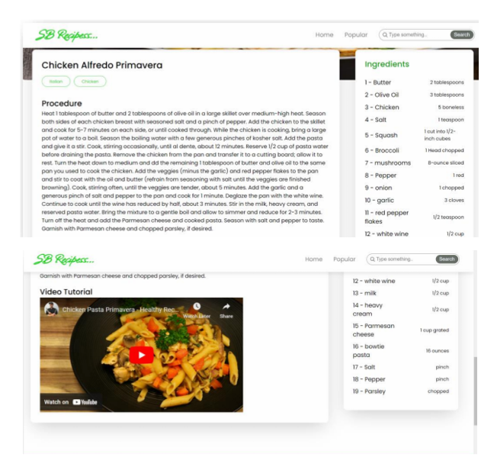

**Conclusion**

CookBook is a comprehensive virtual kitchen assistant that streamlines meal planning, recipe management, and ingredient tracking. By leveraging modern web technologies and AI-driven recommendations, it enhances the cooking experience and reduces food waste. The application provides an intuitive and interactive interface, making kitchen management more efficient and enjoyable. With future enhancements, CookBook aims to be the ultimate solution for home cooks, fitness enthusiasts, and culinary professionals alike.

This document provides a structured and detailed view of the CookBook application, covering all necessary aspects from development to testing. Let me know if you need additional sections or modifications!